Packaging SOP
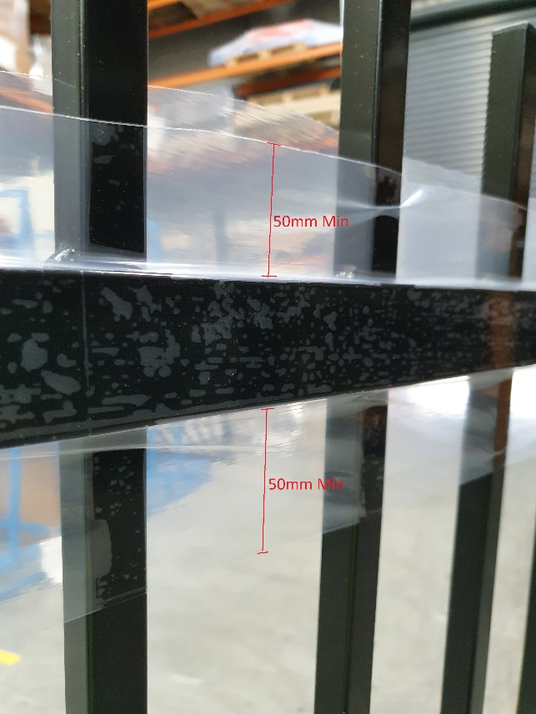
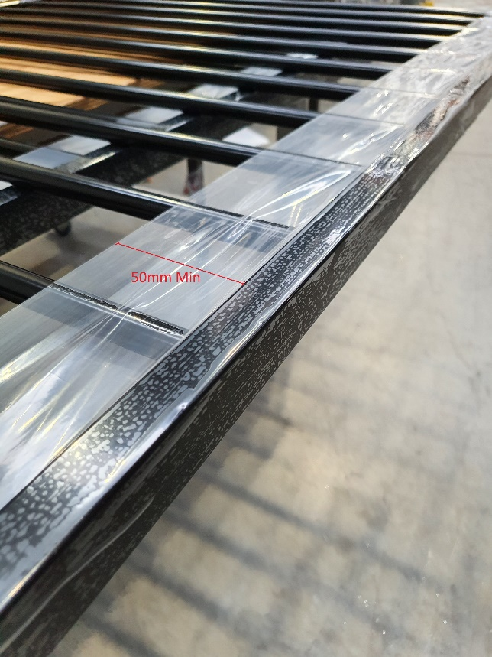
- Cover all rails of each panel with (min 100 micron)?? PE Protective Film. Please ensure the film extends a minimum of 50mm down the verticals.
On panels where the verticals pass through a rail, use two pieces of film, one on each side (min 160mm wide) to cover rail and 50mm of verticals on each side of rail.
On panels where the verticals terminate at a rail, use one piece of film (min 240mm wide) to cover 3 sided of the rail and 50mm down the verticals on each side

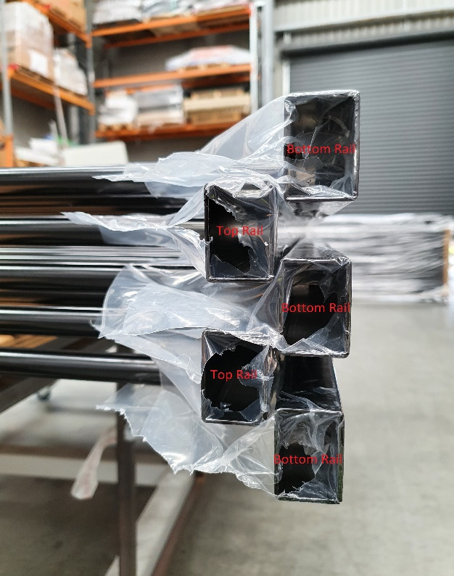
- Stack the panels in bundles of 5, stack these so the bottom rails are on the outside of the stack and the top rails are on the inside. This is to protect the top rail.

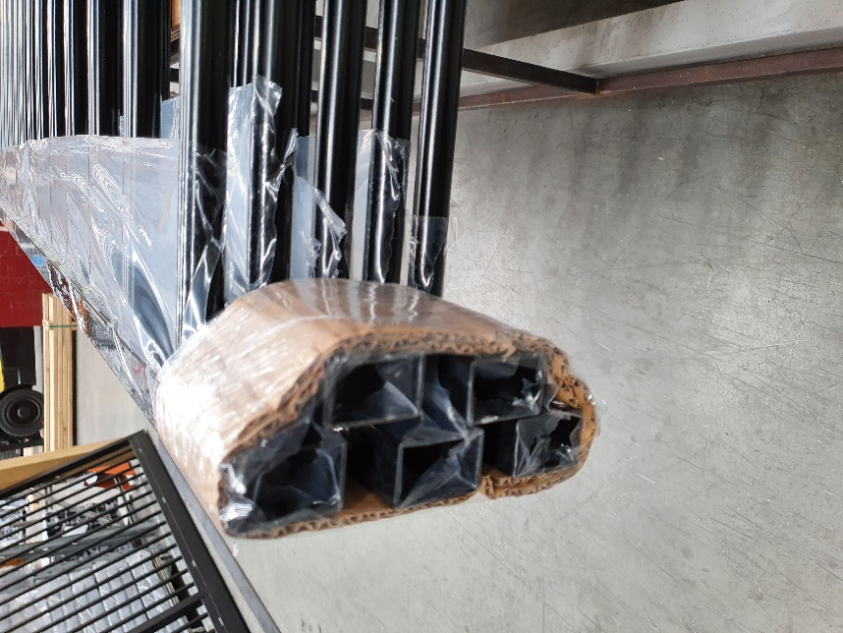
- Cover the ends of the rails with a strip of cardboard 75mm wide and use bundling film over the cardboard to secure the bundle.

- Manufacture steel pallet as per drawing provided

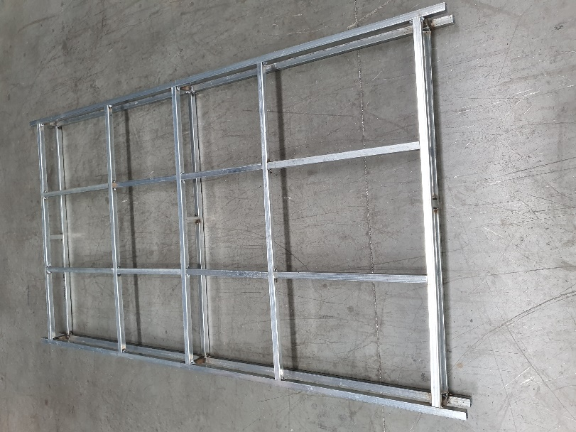

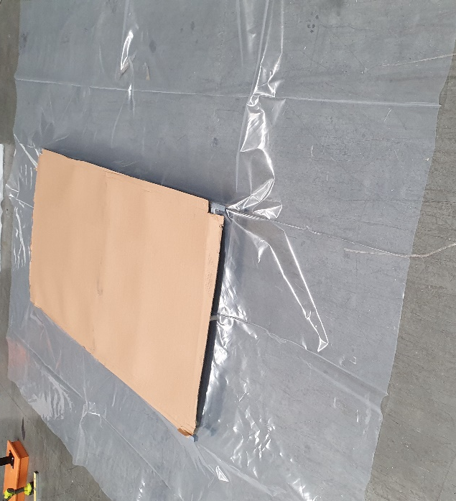
- Place a sheet of ??Micron heat shrink Plastic over pallet. Approx sheet size 2750w by 3750l. Then place a sheet of cardboard (1240x2250mm) on top of plastic.
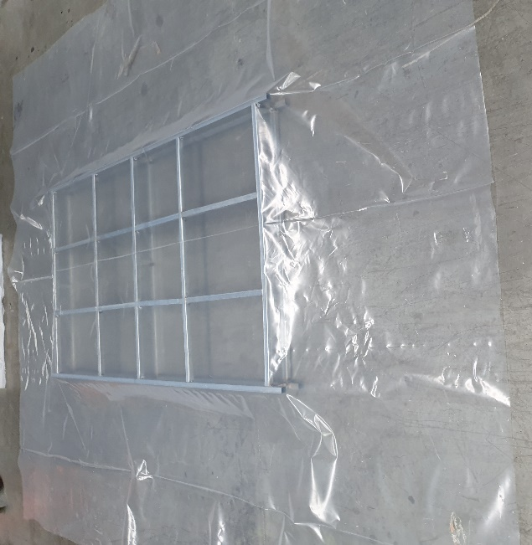

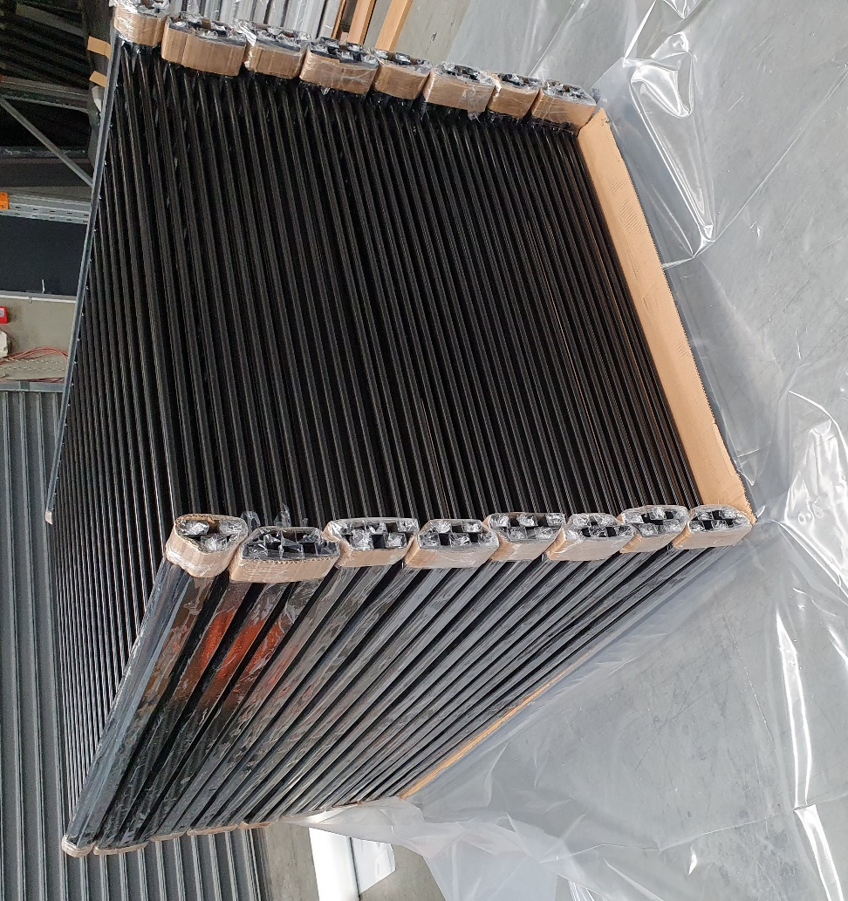
- Stack bundles of panels on the pallet. There must be 7x bundles with five panels in each bundle, and 1x bundle with only three panels in , to make a total of 38x panels on the pallet. Ensure the bundles interlock.

- Cover the top and long sides of pallet with cardboard as shown.

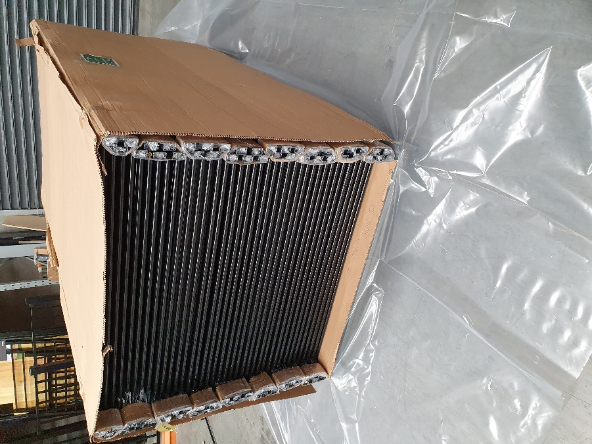

- Fold the bottom sheet of heat shrink plastic up the sides of the pallet, using a small amount of tape to hold the sheet in place.
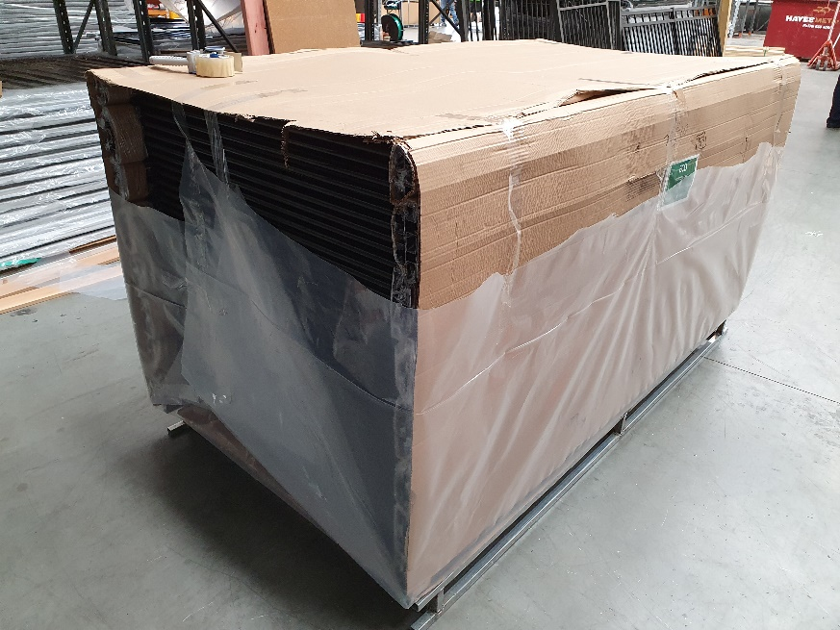
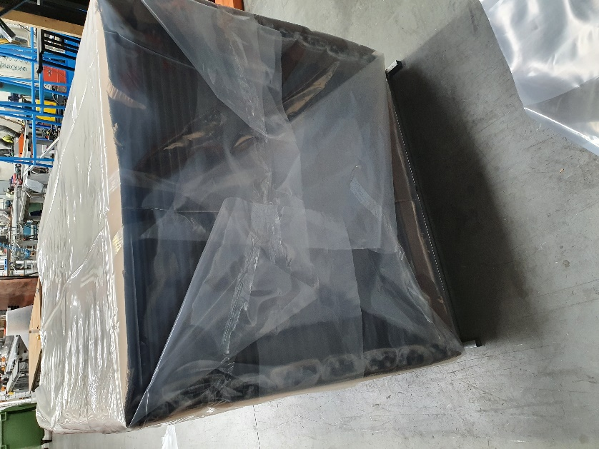
Place another sheet of Heat shrink plastic (2750x3750mm) over the top of the pallet, using a little tape to hold it in place.

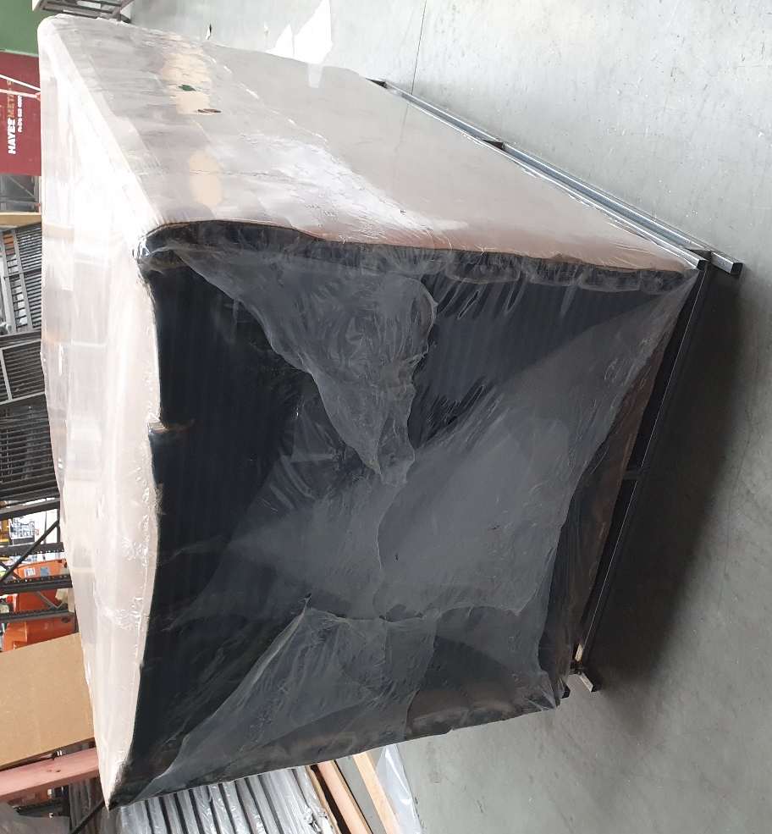
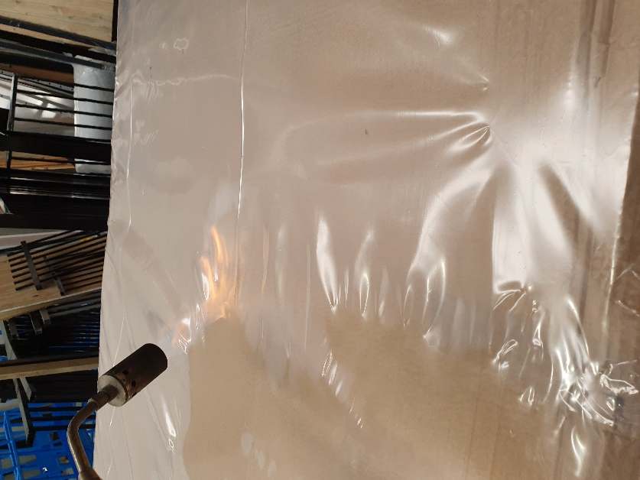
- Using a suitable heat source, heat the plastic so it bonds all joins together, and creates a tight, dustproof seal around the pallet.

- Put 2x straps around pallet, using cardboard corners as shown.
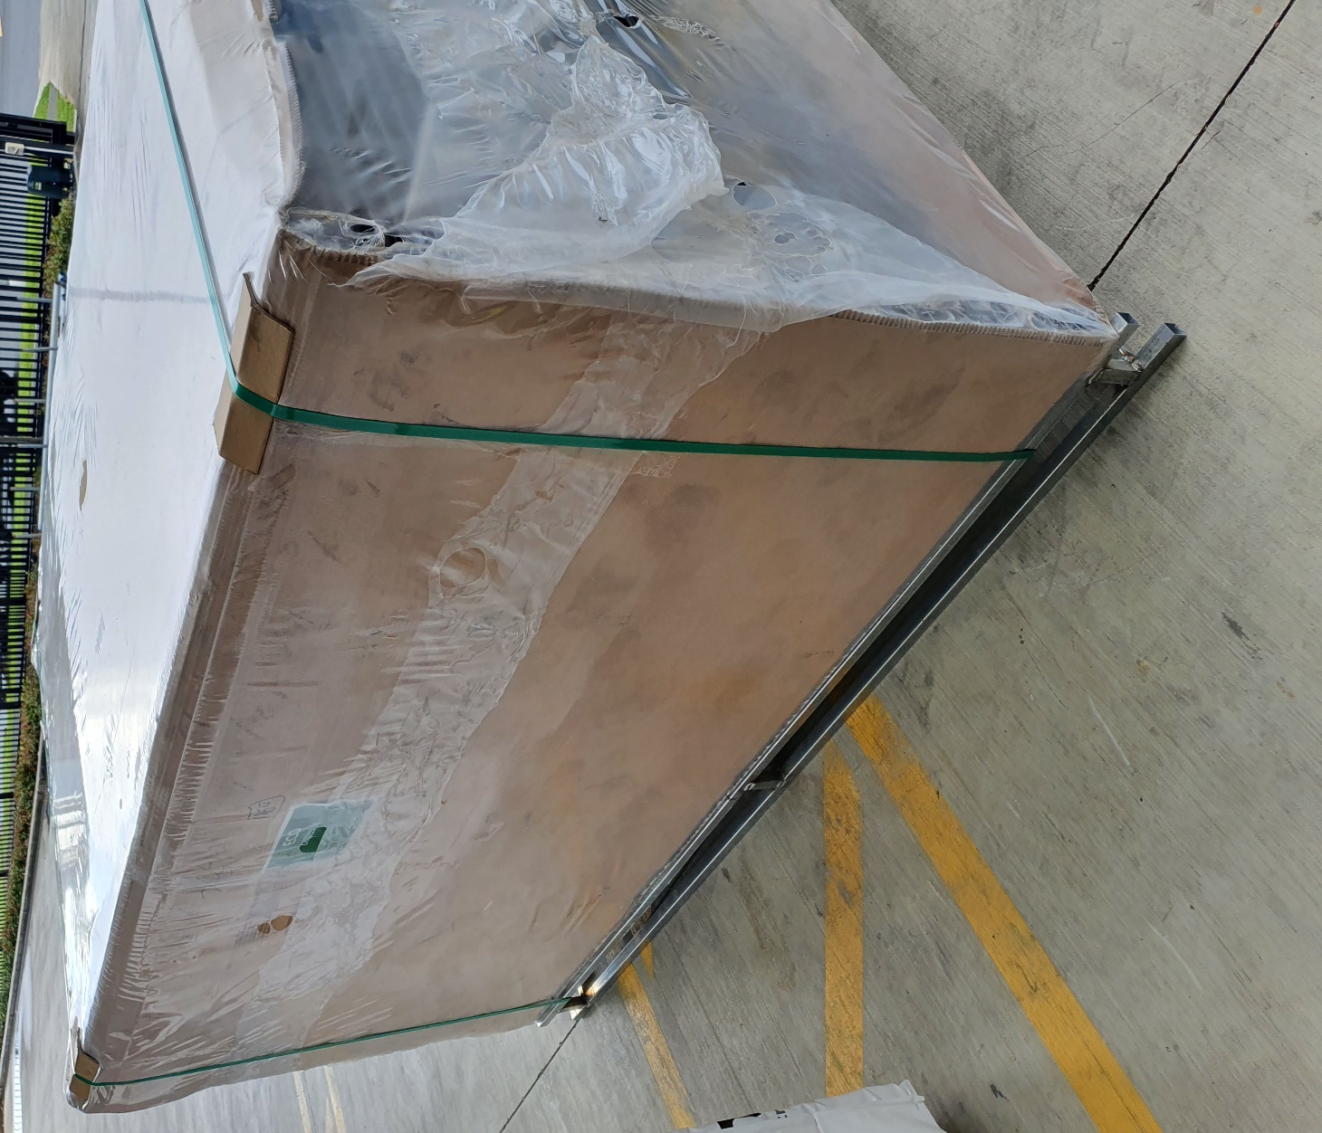
- Attach label to all 4 sided of Pallet as per Boundaryline’s Labelling Guide

