(Logo of your company) | VIETNAM COMPANY’S PROFILE  (Importer)

I/ COMPANY INFORMATION

Company Name
Address
Telephone (s) | +84- |  | +84-
Fax
E-mail (s)
Website
Tax code (company) |  |  | Date:
Legal Capital (US$)
Number of staff (persons)
Trade Value (last year) | Export (US$): | Import (US$):
Main countries
(Export/Import)

LEGAL REPRESENTATIVE CONTACT PERSON

Name  Mr./Ms |  | Name  Mr./Ms
Position |  | Position
E-mail |  | E-mail
Mobile |  | Mobile
Facebook  (if possiple) |  | Facebook  (if possiple))

DETAILS OF BUSSINESS
Main sectors | Manufacturer [ ] | Trading [ ] | Service [ ] Management [ ]
Summary in activities
Products (Imported)

Request for trade fair

II/ IMPORTED PRODUCTS

No | Product Picture (250 pixels max)  (ảnh minh họa sản phẩm XK) | Name, specification of products  (tên, quy cách và giá của SP, tóm tắt)
1 | 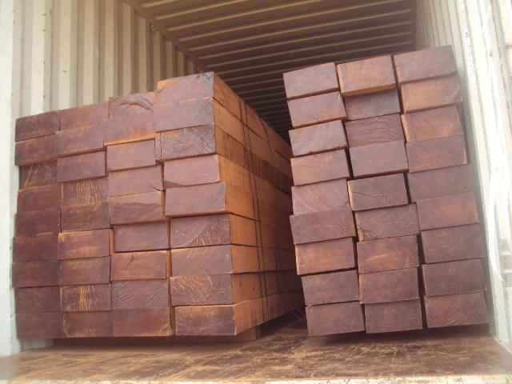  (Thay hình ảnh sản phẩm cần NK) | (Ví dụ cần NK)  Name of product: wood  HS code: 4407990
2

III/ ACTIVITIES OF COMPANY

No | Picture (250 pixels max) | Picture (250 pixels max)
4.1 |   E.g: Head Office  (Thay hình ảnh trụ sở của quý công ty) | 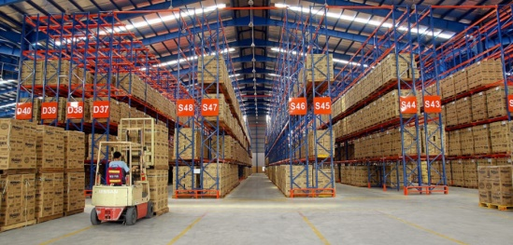  E.g: Warehouse  (Thay hình ảnh nhà kho của quý công ty)
4.3

…
This form filled in & approved by CEO/Director of Vietnam company on: dd/mm/yyyy;
The information declared as above mentioned is true and in accordance with the Commercial law of Vietnam.

*********

Note:
Using the following software to reduce the size of pictures “Capture pictures on the screen”’.
1) http://www.mirekw.com/winfreeware/files/MWSnap300.exe
2) Using “ Spinning Tool” in your computer (Window 7, 8 & 10)

Recommendation & warning by Vietnam Trade Office in Nigeria:
- The payment has to be done by the Irrevocable Letter of Credit At sight (L/C).
- Do not apply: T/T (Telegraphic Transfer) 20% (30%) before shipment, 80% (70%) after shipment, or D/A (Document against Acceptance);
- The exporter and importer have to bear any risk, if do not follow the above recommendation, and are responsible for their transaction of products, payment.

Vietnam Trade Office in Nigeria
(Concurrence with Ghana, Cameroon, Togo, Chad, Sierra Leone & Liberia)
No. 21, The Address Home#1 Estate,
Castlerock Ave., Lekki, C.P. 106104, Lagos city, Nigeria
Mp/WhatsApp: +234 803 474 4486
Emails: ng@moit.gov.vn; VietHoangTuan@gmail.com
https://vnembassy-abuja.mofa.gov.vn
http://en.vietnamexport.com/

