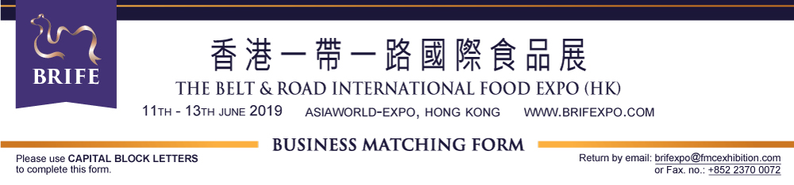

Company Information (“Company”)
Company Name  English: |  |  | Chinese:
Office Address:
We are Exhibitor Buyer / Visitor Other
Company Profile / Product highlight (In 50-200 words):
_________________________________________________________________________________________________________________________________________________________________________________________________________________________________________________________________________________________________________________________________________________________________________________
Brand(s):
Website:
For Organizer’s internal contact:
Contact (Mr. / Ms.): |  |  |  | Job Title:
Contact’s Email: |  |  |  | Contact’s Telephone: / /  Mobile: / /  Country Code City code Number
Type of Business Nature, Products / Services to be Exhibited / Provided / From which Business Region
Business Nature
Academia  Association  Buying Office  Chain Store  Department Store  Distributor  E-commerce Buyer | Embassy / Consulate  E-tailer  Export Agent  Exporter  Franchisee  Franchising Agent  Franchisor |  | Government Institutes  Import Agent  Importer  Manufacturer  Press & Media  Restaurant/Bar  Retailer |  | Service Company  Shopping Mall  Trade Chambers  Wholesaler  Other(s):  _____________________
Agrifood | Beverage (Alcoholic) |  | Food & Catering Franchise |  | Professional Services & Investment
Oil & Cereals / Pulses & Grains  Fresh Fruits and Vegetables  Seafood  Meat & Poultry  Rice & Noodles | Wine  Baijiu (Chinese Spirits)  Spirits  Beer  Others: Soju/rice wine/  .Cocktail/Sake/etc. |  | Restaurant  Shop  Convenient Store  Food & Drink Specialty  Food Retail Company  Consulting Group  Other Franchising Businesses |  | Logistics  Banking  Accounting  Taxation Service  E-Commerce  Legal Service  Financial Service  Investment Fund  Quality Certification  Other Services
Food | Beverages (Non-Alcoholic)
Halal Food  Canned Food  Convenient & Instant Food  Dehydrated Food  Dairy Products  Sauce & Seasoning  Frozen Food  Organic Food  Health Food  Bakery Products  Snacks: Confectionery & Sweets  Other Food | Coffee & related products  Tea & related products  Others: Water/Soft Drinks/  .Energy Drink/Milk/etc.
 | Equipment & Packaging |  | Business Region (Please specify the countries & regions):  ___________________________________________________________  ___________________________________________________________
Food Packaging
Food Processing Machinery
Food Equipment & Technology
Other Equipment
What type of Business Nature, Products and/or Services are you looking for? And for which region?
Business Nature
Academia  Association  Buying Office  Chain Store  Department Store  Distributor  E-commerce Buyer |  | Embassy / Consulate  E-tailer  Export Agent  Exporter  Franchisee  Franchising Agent  Franchisor | Government Institutes  Import Agent  Importer  Manufacturer  Press & Media  Restaurant/Bar  Retailer |  | Service Company  Shopping Mall  Trade Chambers  Wholesaler  Other(s):  _____________________
Agrifood | Beverage (Alcoholic) |  | Food & Catering Franchise |  | Professional Services & Investment
Oil & Cereals / Pulses & Grains  Fresh Fruits and Vegetables  Seafood  Meat & Poultry  Rice & Noodles | Wine  Baijiu (Chinese Spirits)  Spirits  Beer  Others: Soju/rice wine/  .Cocktail/Sake/etc. |  | Restaurant  Shop  Convenient Store  Food & Drink Specialty  Food Retail Company  Consulting Group  Other Franchising Businesses |  | Logistics  Banking  Accounting  Taxation Service  E-Commerce  Legal Service  Financial Service  Investment Fund  Quality Certification  Other Services
Food | Beverages (Non-Alcoholic)
Halal Food  Canned Food  Convenient & Instant Food  Dehydrated Food  Dairy Products  Sauce & Seasoning  Frozen Food  Organic Food  Health Food  Bakery Products  Snacks: Confectionery & Sweets  Other Food | Coffee & related products  Tea & related products  Others: Water/Soft Drinks/  .Energy Drink/Milk/etc.
 | Equipment & Packaging |  | Business Region (Please specify the countries & regions):  ___________________________________________________________  ___________________________________________________________
Food Packaging
Food Processing Machinery
Food Equipment & Technology
Other Equipment
Acceptance:
The information provided by the above listed Company to FMC Exhibition Co. Limited (“Organizer”) will be used by the organizer mainly for, but not limited to, the BRIFE 2019, and will be used for any legally permissible purpose in Organizer’s sole discretion

We are interested to make appointment with these exhibitor(s): ________________________________________________________________
Preferred Meeting Schedule (Please select at least 3 sessions)
11 June 2019 (Tuesday) |  | 12 June 2019 (Wednesday) |  | 13 June 2019 (Thursday)
10:00 – 11:00  11:00 – 12:00  13:00 – 14:00  14:00 – 15:00 | 15:00 – 16:00  16:00 – 17:00  17:00 – 18:00 | 10:00 – 11:00  11:00 – 12:00  13:00 – 14:00  14:00 – 15:00 | 15:00 – 16:00  16:00 – 17:00  17:00 – 18:00 | 10:00 – 11:00  11:00 – 12:00  13:00 – 14:00  14:00 – 15:00 | 15:00 – 16:00
Duration of each meeting will be around 30 -45 minutes (We will confirm you the meeting schedule later.)
Required: Yes (Language: ___________________) No
Remarks: 1) The Organizer will review your application, and issue the confirmation letter to successful applicants by the end of .May.
2) Maximum. 2 representatives from the same company can apply the business matching program.
3) The cost of the translation service will be paid by the requesting party, and the Organizer will provide .recommended service provider.

We, hereby, certify that the above information given are true and correct, and we agree to the Acceptance Terms listed above.
Company stamp
__________________________________________________

Company Name
__________________________________________________
Authorized Signature
Name (in capital letter): _______________________________
Title / Position: ______________________________________ Date: ________________________

