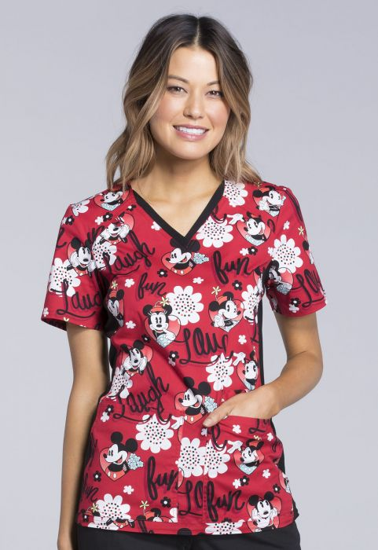
Body
97% cotton / algodón
3% spandex / elastano
Side panels and neckband
88% polyester
12% spandex / elastano

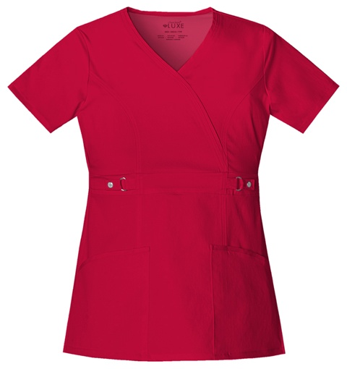
51% polyester
46% rayon
3% spandex
Or
100% cotton

Or

97% cotton
3% spandex

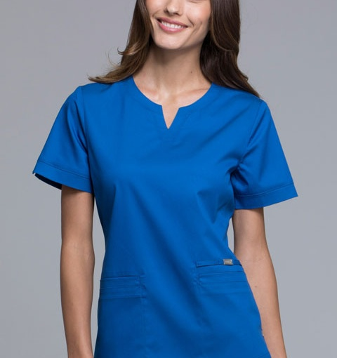
51% polyester
46% rayon
3% spandex
Or
100% cotton

Or

97% cotton
3% spandex

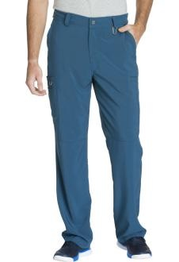
Men’s pant

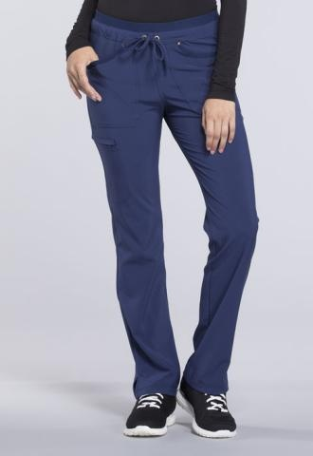
Women´s pant

