a
Organizer: Pomurski sejem d.o.o.
Contact: Mr Boris Nicolas Erjavec, Executive Director, T+386 2 564 2 115, M +386 31 346 126, E boris.erjavec@pomurski-sejem.si
Location: Gornja Radgona / Pomurski sejem


26. – 31. 8. 2023

International Fair of Agriculture and Food


21. – 24. 9. 2023

International Fair of Defence, Security Protection and Rescue


2023

International Construction Fair


2023

International Fair of Sustainable Technologies and Green Lifestyle


2024

International Hunting and Fishing Fair


2024

International Hunting and Fishing Fair


2024

International Fair for Outdoor Activities and Recreation


2024

International Fair of Modern Medicine



International Funeral and Cemetery trade Fair

Organizer: Celjski sejem d.d.
Contact: Ms Nina Ermenc Pangerl, Vice president of the Management Board, T +386 3 54 33 200, E nina.ermenc@ce-sejem.si
Location: Celje / Celjski sejem

OCTOBER 2022, 22 - 23

POMP – FAIR OF POMPOUS EVENTS

MARCH 2023, 17 - 19

GREEN VITA – ALTERMED & FLORA

MARCH 2023, 17 - 19

FESTIVAL KAVE SLOVENIJA / cOFFEE FESTIVAL OF SLOVENIA

MARCH 2023, 17 - 19

SVET LOVA IN RIBOLOVA / WORLD OF HUNTING AND FISHING

MARCH 2023, 18 - 19

APISLOVENIJA

APRIL 2023, 18 - 21

INTERNATIONAL GOSPODARSKA VOZILA IN LOGISTIKAINDUSTRY FAIR

MAY 2023, 17 - 19
KOMOT – iNDUSTRIAL SOLUTIONS AND INNOVATIONS in the field of utilities, drinking water supply, wastewater disposal and treatment and waste management

MAY 2023, 18 - 21

AVTO IN VZDRŽEVANJE / CAR & mantainence

MAY 2023, 18 - 21
GOSPODARSKA VOZILA IN LOGISTIKA / COMMERCIAL VEHICLES AND LOGISTICS

SEPTEMBER 2023, 13 - 17

55. MOS / 55th international trade fair

NOVEMBER 2023, 24 - 25

EROTICLAND

NOVEMBER 2023, 24 - 25

SLOVEROTIKA

Organizer: Ljubljana Exhibition and Convention Center
Contact: Anja Mijatović, Manager of Congress and Event Department, T +386 (1) 300 26 50, E anja.mijatovic@gr-sejem.si
Location: Ljubljana/Gospodarsko razstavišče


https://www.furniture-fair.si/


https://www.nature-health.si/


https://www.alpeadria.si/en/

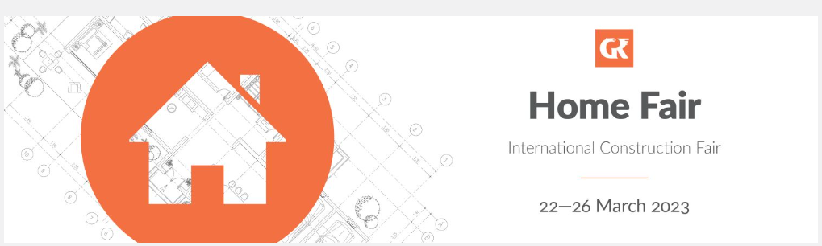
https://www.home-fair.si/

