BHB GmbH Projektmanagement * Schillerstraße 18 * 76135 Karlsruhe * Germany  To Whom It May Concern | 08.04.2016

OFFER Timber from South-Sudan and Uganda


Dear Sirs,

In co-operation with our friends in South-Sudan and Uganda, we are pleased to offer several kinds of timber. Presently we have a government confirmed export license for 100 x 20” Container. It is possible to get additional licenses depending on demand.

Our co-operation partners have a registered company and are working very closely with the Ministry of Agriculture, Forestry, Cooperative and Rural Development in South Sudan and the local private growers to source the required quantities of timber logs or beams that are ordered by the clients. The same quantities will be marketed and delivered to the clients based on the arrangement made by the two parties; in case of local demand the product will be delivered to the traders or carpentry workshops.

The Governments has banded the export of logs. It is only allowed to export processed timber. We are able to cut into any size you may look for. Please do not hesitate to contact us and send us your needs. We will be pleased to offer.

Presently we can offer:

No. | Botanical Name | Short name  (DIN EN 13556) | Other name | Other name | Picture
1. | Dialium Corbisieri |  | Eyoum; Dialium corbisieri Staner | Kalanga | See picture 01
2. | Entandrophragma cylindricum | ENCY | Sapelli | Liboyo II | See picture 02
3. | Chlorophora excels; Milicia excelsa | MIXX | Iroko (Kambala) | Punga – Mbala – Muvula | See picture 03
4. | Autranella congolensis | AWCO | Mukulungu | Mbanda, Afri-Kulu | See picture 04
5. | Khaya anthotheca | KHXX | Acajou D´Afrique / African Mahogany | Linzo | See picture 05
6. | Khaya grandifoliyola | KHXX | African Mahogany, Large-leaved Mahogany
7. | Khaya ibrorentis | KHXX | Mahagony
8. | ….more varieties | KHXX | Mahagony
9. | Tectona grandis | TGTR | Teak
10. |  | DSXX | Ebony black
11. |  | DSXX | Ebony white

If you need any other type of tropical timber, please let us know.

With kind regards

Burkhard Buß
Managing Director

Sample for our stock in the factory in Uganda und South-Sudan

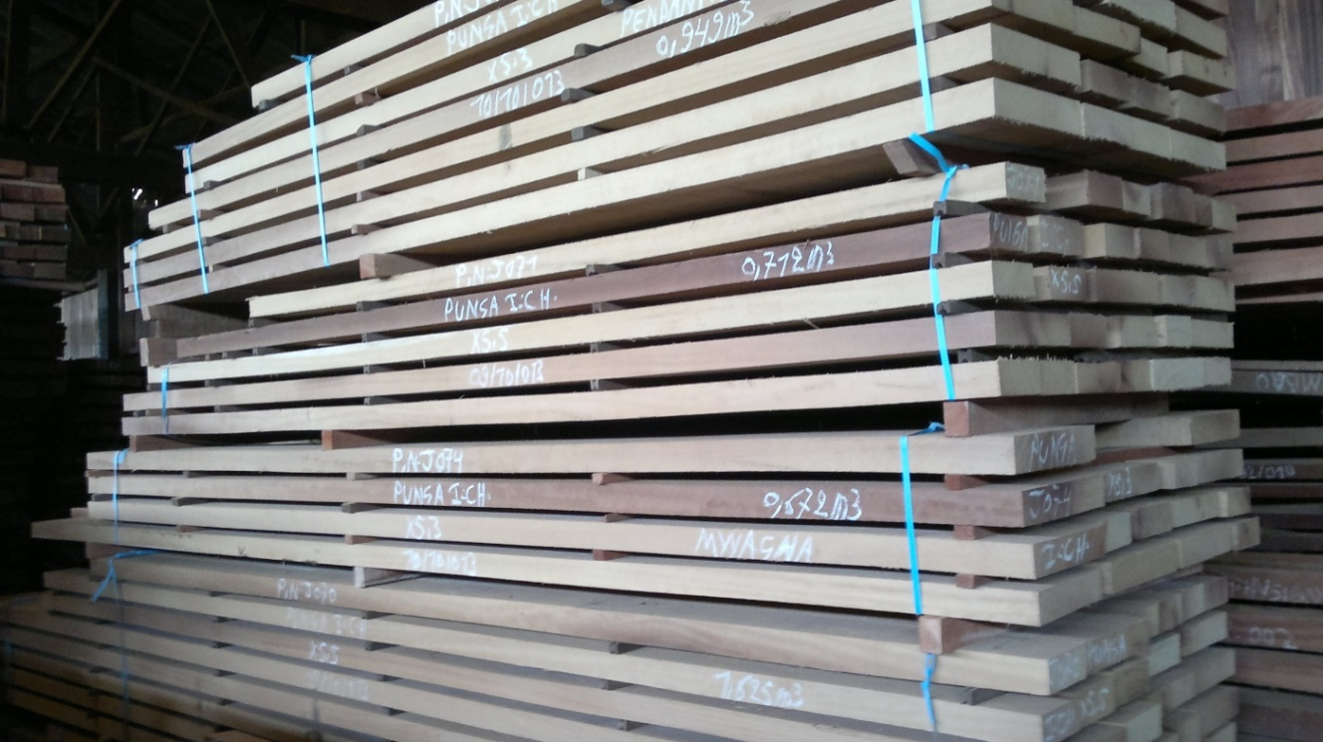

Picture 01 - Dialium Corbisieri


Picture 02 - Entandrophragma cylindricum
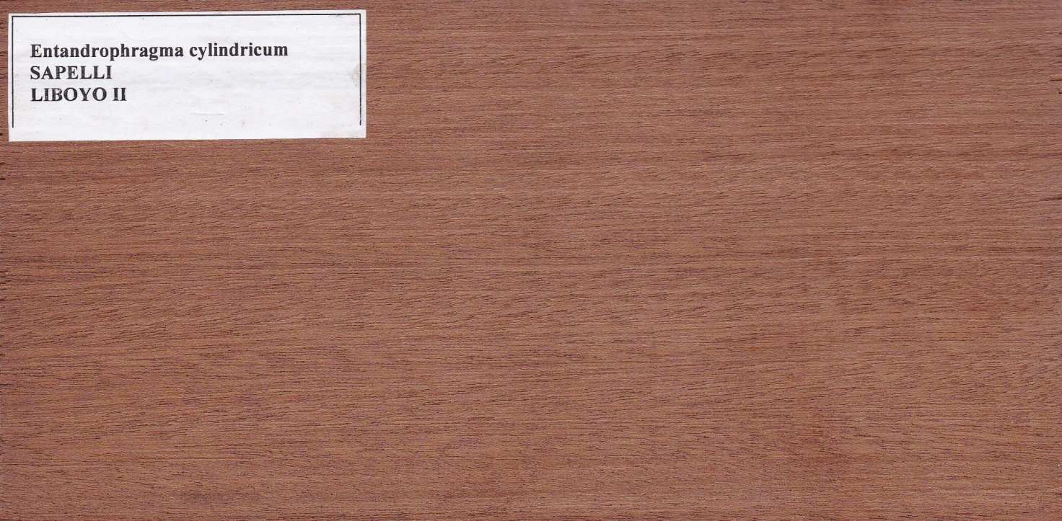

Picture 03 - Chlorophora excels


Picture 04 - Autranella congolensis


Picture 05 - Khaya anthotheca


